Instructions in a nutshell
- Sign into the database (once you have been entered by your HOME league)

- If this is your first time to sign in, check your personal info in the screen that pops up. Answer YES or NO concerning its accuracy. Click on VIEW ARTWORK and go to Step 4.

- If this is not your first time in the database, the first thing you will see is a list of the artwork that you need to review for accuracy.
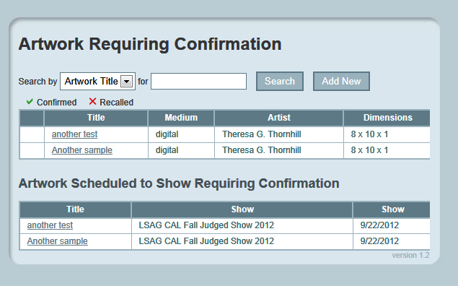
- CONFIRM or RECALL artwork info you see there. (Note changes that need to be done in the pop-up box. An email with your note will automatically be sent to the league that must make the corrections.)

In this example I clicked on “another test” in the Title column. Now you see a screen like this-
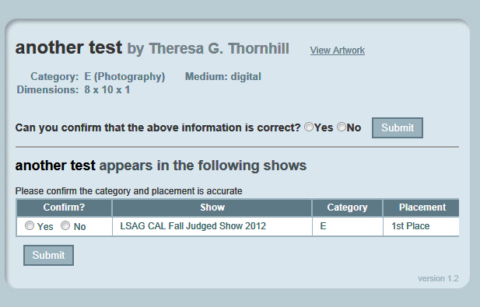
- #4 is a two-step process. First, you need to confirm your dimensions, title and category. Second, you need to confirm the placement of each piece as recorded by the judged show. If you need to have an error fixed, a box will appear after you click on "NO" so you can report what the problem is. Your report is then sent to the person who needs to make those corrections.
I selected YES by putting a check mark in the round circle and then hit the SUBMIT button. A action box pops up to ask if you are sure you want to confirm. Say OK. Now you see this and the message “Your confirmation has been received”
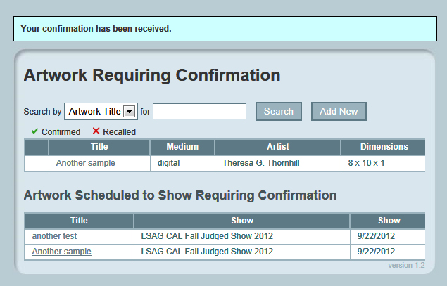
That is the first step of this two-step process.
Now click on the title of the same artwork you just confirmed for Title and Dimensions. It is listed under Artwork Scheduled to Show Requiring Confirmation. Now you see this:
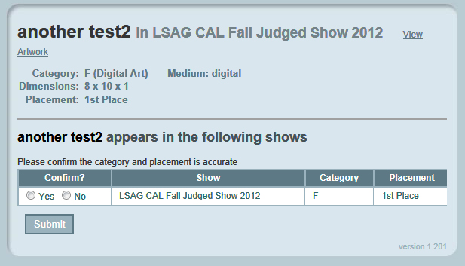

After you hit YES, you see this screen with the message “Your choices have been updated”. If you have additional art, click on VIEW ARTWORK to be taken back to your list. If not, continue to registration.
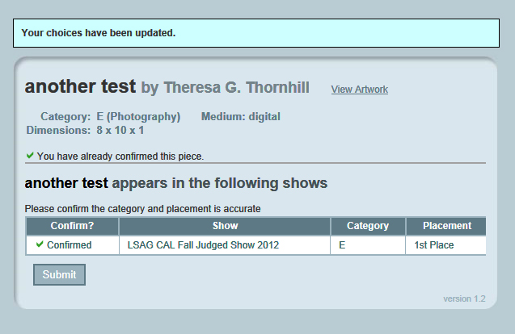
Registration Instructions

- Click on the REGISTRATION tab on the left-hand side of the screen.

- Select the artwork you want to register by clicking the box next to the Title, check the "For Sale" box and add a price IF it is for sale.
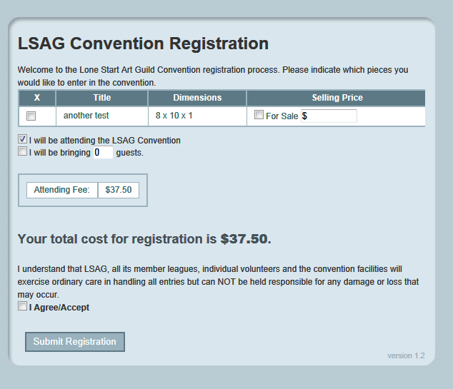
IMPORTANT—Make sure that ALL of the art you want to take to the convention is selected here. If you don’t see a piece of artwork you want take—you have missed a step in the confirmation process. See step 5 above.
If you realize you have more artwork, go to the PROFILE tab and then click on VIEW ARTWORK. Repeat step 5 above.

I did that and now I see this:
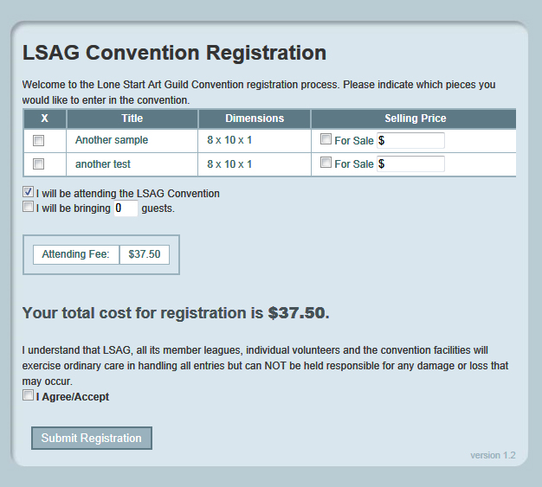
- Indicate if you are attending or not attending, enter the number of guests
- Click the box next to "I agree/accept"
- SUBMIT
- PRINT and send a copy along with your check made out to your HOME league. HOME league contact and address is printed at the bottom of the receipt.

