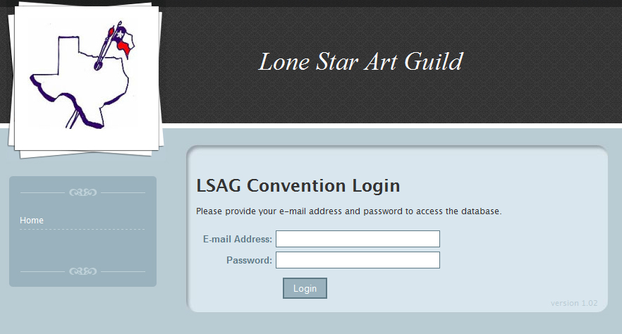
Go to www.lonestarartguild.org, then SHOW DATABASE (last link in the list). Click the link then click Show Database again.
Sign in with your email (as provided to LSAG’s Winners List Person) and use the password you’ve been assigned.
Judged Show chairs are given Level 3 access. Assistants are Level 2

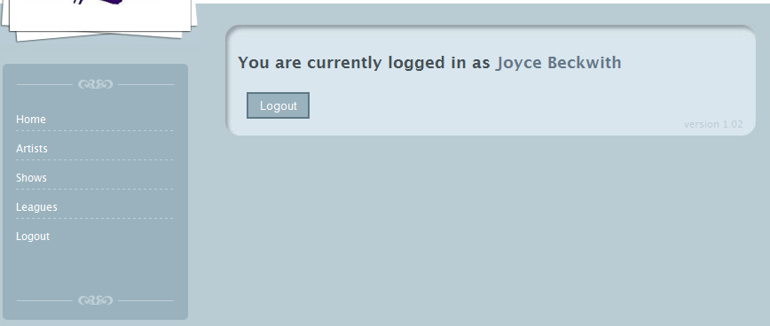
Go to the ARTISTS tab
Click on ADD NEW
Key in each of your league’s artists’ information.
You will need NAME, ADDRESS, PHONE, EMAIL, and their DIVISION
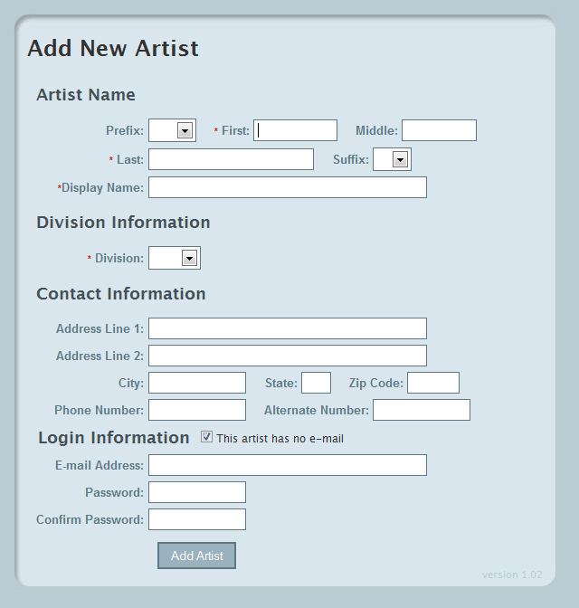
Enter each artist’s information including an email.
If the box “This artist has no e-mail” is checked then confirming emails about artwork and awards will go-- by default-- to the judged show person for the league who hosted the judged show for confirmation of that artist’s reported show award(s).
All artists who are entered in our database will get an email asking them to sign into the database to confirm their personal contact info and to assign themselves a password. This will not start until after Feb 4---your deadline to get artists and fall show results keyed in.
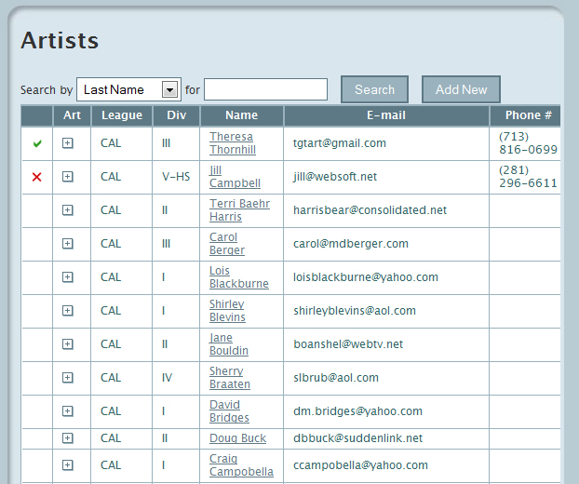
Once you have keyed in all of your artists, your screen will look like this.
You are now ready to key in:
Your league’s Fall Show information
Artwork information
Category and Award earned for each artist who participated in your show.

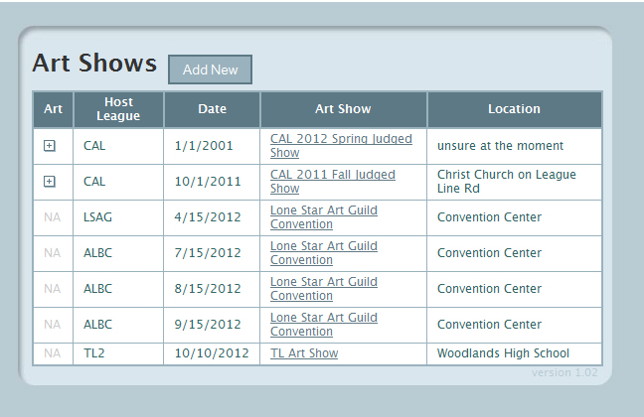
Go to the SHOWS tab
Click ADD NEW
(All shows will pop up but you will only be able to modify your league’s show(s).)
Key in your league’s fall show information.
Click on SAVE SHOW
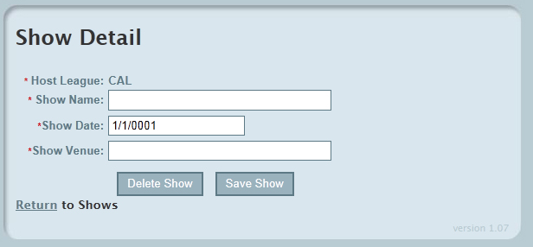
You will be brought back to the listing of Art Shows..
Click on the + sign under art for the show you would like to report show results for.

Now you see the next screen---
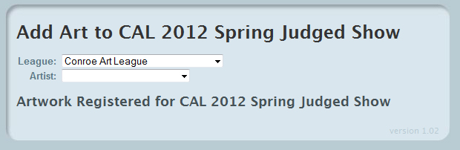
Both boxes here are drop down menus. First choose the league an artist calls HOME then choose the Artist you will be reporting show results for.
If an artist is not in the drop down menu you can say ADD NEW and key the artist on behalf of another league—THIS YEAR ONLY!
In the box called ARTWORK TITLE (which pops up after you selected your artist): say ADD NEW
Another screen opens-----
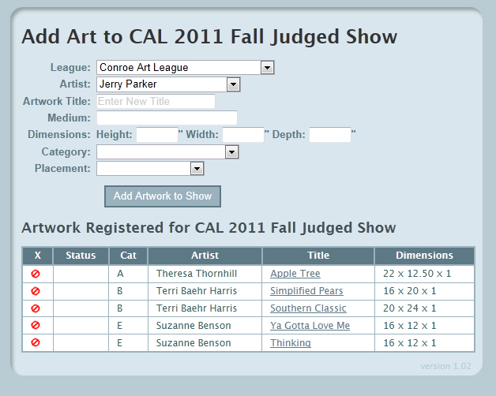
Key the following:
Artwork Title Actual Medium—ex. Graphite pencil Dimensions—(required info)
Category (drop down) Placement (drop down) Then hit ADD ARTWORK TO SHOW

After Feb 4, 2011----An email will go to all artists in the database so they can activate themselves and use the system. Once they update their password they will either Confirm or Recall their personal information and later their show results.
“Confirmed” will place the artist and artwork in a list as “Eligible for LSAG Convention Registration”
“Recalled” means the artist has found an error in either artwork information or award. “Recalled” will alert the judged show person at the league where the art was awarded so they can re-check the info and make corrections. Once that is done, another email goes to the artist to “Confirm”.
Leagues have until February 4th to key in their artists and Fall Judged Show Results.

